RESOLUTION NO.__________

RE: CERTIFICATE OF APPROPRIATENESS UNDER THE
PROVISIONS OF THE ACT OF THE PENNSYLVANIA
LEGISLATURE 1961, JUNE 13, P.L. 282 (53
SECTION 8004) AND BETHLEHEM ORDINANCE NO.
3952 AS AMENDED.

WHEREAS, it is proposed to construct a 6 ft. x 6 ft. addition to the rear porch, remove and replace existing steps and replace columns at 228 E. Market St.

NOW, THEREFORE, BE IT RESOLVED by the Council of the City of Bethlehem that a Certificate of Appropriateness is hereby granted for the proposal.

Sponsored by: (s)

(s)

ADOPTED BY COUNCIL THIS DAY OF

(s)
President of Council

ATTEST:

(s)
City Clerk

HISTORICAL & ARCHITECTURAL REVIEW BOARD

The applicant proposes to construct a 6 ft. x 6 ft. addition to the rear porch, remove and replace existing steps and replace columns at 228 E. Market St.
APPLICATION #1:

Norman & Doreen Roberts
228 E. Market St.
Bethlehem, PA 18018

OWNER:

__________________________________________________________________

The Board upon motion by Marsha Fritz and seconded by Nancy Shelly adopted the proposal that City Council issue a Certificate of Appropriateness for the following:

- New foundation to be veneered with a synthetic stone matching in color
and pattern the existing stone foundation.

2. The decking will be 1” thick prefinished porch flooring by Wolf in Villager Grey
color.

3. New porch posts will be fiberglass matching the existing in color and detail.

4. Rails to be cedar to match existing.

5. Porch flooring should have the smooth side exposed.

6. The motion was unanimously approved.

__________________________________________________________________________

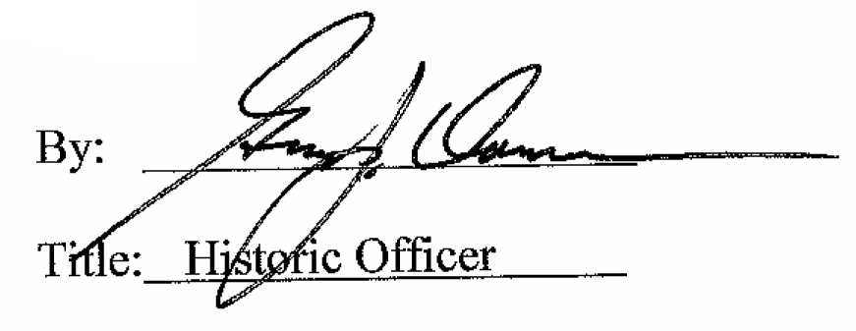

Date of Meeting: May 4, 2016

